Think About What You Think

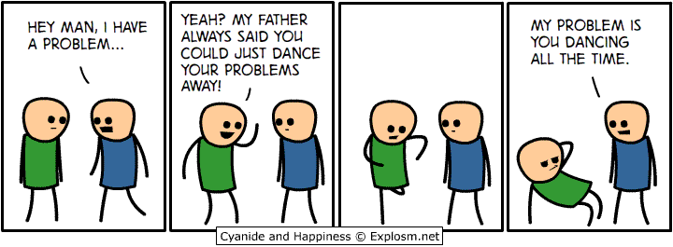
"In countering the effects of a problem-saturated story, it is important to develop as rich, detailed, and meaningful a counter-story as possible." ~ Freedman and Combs

Food For Thought...
Underneath a problem-saturated story are hidden stories of strength and possibility that are overshadowed by the problem.
Think about this statement as you watch the video and complete the rest of the assignment. Make sure you follow "the instructions."

The Prompt
Actively listening to the problem-saturated stories of your clients is one of your most important responsibilities you have, especially when using narrative therapy. A person’s life can be an all consuming perpetual narrative of dominant stories. These stories of gender, race, class, age, sexual orientation, religion (just to name a few) can be so permanent and entrenched in the culture that we can get totally caught up in them without ever knowing it. So, it can be a daunting challenge when your client is caught up in a constellation of unstoried moments.Nonetheless, a narrative therapist operates from a belief that the "problem story" is only one of many stories about the person. Although it can be disturbing and uncomfortable, listening carefully to problem-saturated stories can also be incredibly valuable for uncovering hidden stories and experiences and rewriting past narratives of identity.

The Instructions
- Watch the "Animated Narrative Therapy - Dot Exercise of Jill Freedman and Gene Combs"video here.
- Referencing the video, your textbook, and other resources, discuss how problem saturated stories can be used to improve client outcomes in narrative therapy.
- Based on the critiques of narrative therapy, what are some of the challenges that may occur when using a narrative therapy counseling approach?
- Reference your source(s) of information in your reply.
- Respond to at least two of your classmates.
- Word count is 300 - 500 words.

Note:
- You must submit a post BEFORE you can see your classmates posts.
- Ideally, your response to your classmates should consist of a complete thought that contributes to the dialogue and furthers the discussion.
- There are no right or wrong responses, so share your knowledge, insights and thoughts freely, but please be respectful to one another as you explore and discuss your ideas.
- See the discussion rubric (in rubric link on the navigation bar) for grading criteria.

